Trie based dictionary for Chinese

Daixuan Chen Shulin Wen Fan Zhang

Computer Science Computer Engineering Computer Engineering

Stevens Institute of Technology Stevens Institute of Technology Stevens Institute of Technology

***Abstract* —** **This paper proposes a highly efficient technique for the retrieval of Chinese characters by implementing the trie data structure in the search process. The trie data structure enables effective partitioning and storage of Chinese characters, ensuring they can be easily accessed from root to leaf nodes. Concurrently, the integration of a hashmap offers direct mapping, which expedites the retrieval of these characters. We present both pinyin and shuangpin methods as viable strategies for searching Chinese characters. Through rigorous experimental analysis, it is demonstrated that the shuangpin method outperforms the pinyin method in terms of insertion time, search time, and space utilization.**

***Key words*—Tries, Hashmap, Chinese, Java**

Ⅰ. Introduction

Research indicates that the scale of data and databases in various industrial sectors is experiencing exponential growth on a daily basis. Concurrently, there is a rising number of web search engines, such as Google, emerging to facilitate information retrieval from the vast expanse of the Internet. The Internet's unparalleled growth and application are reshaping the operational patterns of businesses [1]. A search engine uses an inverted index to respond to queries [2].

The TRIE algorithm, extensively utilized in information processing. Its name, 'TRIE', originates from the word 'retrieval'. [3] coined this term for TRIE memory and [4] introduced the classical algorithm on TRIE. The TRIE algorithm matches a pattern by segmenting all patterns and storing them within a tree structure. Each child node shares a common prefix. Pattern matching involves identifying matches from the root to a leaf node. One of the advantages of trie is that it allows fast access to entries with common prefixes, which is very important when searching similar entries [5].

The skill of hashing is also employed to maintain the mapping since it is always supposed to be an efficient accessing method of data from key sequences to Chinese characters [6]. It facilitates direct retrieval of Chinese characters from the map.

In this paper, we employ an efficient data structure, leveraging both a trie and a hashmap, to store and search for Chinese words. Our paper is structured as follows. Section 1 presents our ideas for searching Chinese characters at the beginning of the project. Section 2 discusses the classes and its functions of the pinyin and shuangpin methods. Section 3 elaborates on the experimental results and subsequent correlation analysis. Finally, Section 4 draws conclusions from our study, outlining the advantages and disadvantages of the pinyin and shuangpin methods discussed.

Ⅱ. Problem Statement

There are two possible ways to implement a trie data structure, pinyin and strokes.

(1) The Chinese characters are broken down into pinyin based on their pronunciation, and stored in a similar way to English words by using this method.

There are two examples that show how a Chinese character is broken down into pinyin.

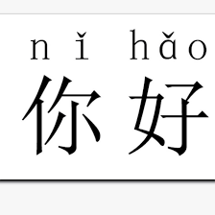

Fig. 1 “Hello” in Chinese, with tone, which can be decomposed as “ni” and “hao”

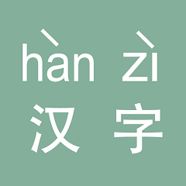

Fig. 2 “Chinese word” in Chinese, with tone, which can be decomposed as “han” and “zi”

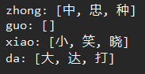

Fig. 3 Sample output

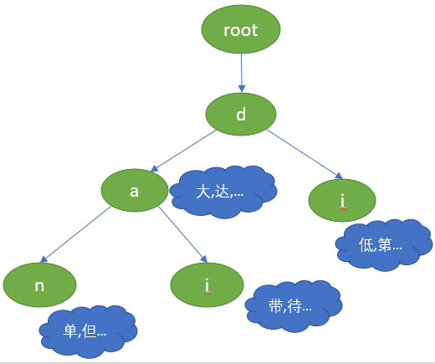

Fig. 4 Data structure of a trie

(2) The Chinese characters are broken down into strokes in order, and each stroke becomes a node in the trie data structure.



Fig.5 “Language” in Chinese with strokes

A Chinese character can be decomposed of the order of strokes, for example, dot, horizontal line, vertical line, left-failing horizontal, right-failing horizontal. In our project we chose pinyin to implement the tries. The following are the reasons:

1. More dataset available
2. More optimization approaches
3. More understandable
4. More GitHub projects and Java libraries that may be useful

Ⅲ. Design Process

(1). Using pinyin to load data

In this method, a Trie (prefix tree) data structure is used to efficiently store and query Chinese characters based on their pinyin (Romanized representation). Here is a brief description of the approach:

1. Define a TrieNode class, which represents a node in the Trie. Each TrieNode contains a mapping of child nodes and a mapping of pinyin to a list of corresponding characters.
2. Define a ChineseTrie class, which contains the root TrieNode. The ChineseTrie class has methods for inserting a character with its associated pinyin and searching for characters based on their pinyin.
3. To use the ChineseTrie class, insert pinyin and character pairs into the Trie, and then query the Trie with a given pinyin to retrieve the associated characters.

TrieNode class: The TrieNode class represents a node in the Trie. Each TrieNode has the following attributes:

1. children: A mapping of characters to their respective child TrieNodes.
2. pinyinToCharacters: A mapping of pinyin strings to a list of Chinese characters that share the same pinyin.
3. isWordEnd: A boolean flag indicating whether the current TrieNode represents the end of a valid pinyin string.

ChineseTrie class: The ChineseTrie class contains the Trie's root node and provides methods for inserting and searching characters based on their pinyin. Here are the main methods:

1. Insert (String pinyin, Character character): This method is responsible for inserting a character with its associated pinyin into the Trie. It starts at the Trie's root node and iterates through the characters in the pinyin string. For each character, it checks whether a child node with the same character exists; if not, it creates a new TrieNode and adds it as a child. It then proceeds to the next character in the pinyin string, using the child node as the new starting point. When the end of the pinyin string is reached, it sets the isWordEnd flag of the final TrieNode to true and adds the Chinese character to the pinyinToCharacters mapping of that TrieNode.
2. Search (String pinyin): This method queries the Trie for Chinese characters based on their pinyin. It starts at the Trie's root node and iterates through the characters in the pinyin string. For each character, it retrieves the corresponding child TrieNode and proceeds with the next character. If a child TrieNode is not found at any point, the search is terminated, and an empty list is returned. If the Trie traversal reaches the end of the pinyin string and the final TrieNode's isWordEnd flag is true, it returns the list of Chinese characters associated with the given pinyin in the pinyinToCharacters mapping of the final TrieNode. If the isWordEnd flag is false, an empty list is returned.

The time complexity for insert and search function is O(L). The space complexity for this datastructure is O(nL).

To use the ChineseTrie class, create a new instance and insert the pinyin and character pairs as required.

Ⅳ. Results and Analysis

We use chinses pinyin data set collected from the internet, combined with Pinyin4j, which is a popular Java library used for converting Chinese characters to their Pinyin representations. The efficiency of this trie data structure is determined by its reading speed (the time required to read the entire database) and querying speed (the time required to query a specific character). The reading speed is measured by recording the time loading a txt file that contains 3500 Chinese characters and 9901 characters. The searching speed is measured by implementing a random retrieval of a Chinese character from the constructed Trie and test the average search speed.

The time required for original pinyin Trie to insert 3,500 commonly used Chinese characters is 25 milliseconds and for a dataset with 9901 Chinese characters is 39 milliseconds.

The average time needed to randomly search for a pinyin in the Trie and find the corresponding character is 477.7 nanoseconds and for a dataset with 9901 Chinese characters is 594.0 nanoseconds.

Ⅴ. Conclusion

In summary, the pinyin-based Trie method offers an efficient and space-saving way to store and query Chinese characters based on their pinyin. However, it has some limitations, such as incomplete pinyin-to-character mappings, reliance on accurate pinyin input, and potential memory overhead for large character sets. The following is its advantages and disadvantages.

Advantages:

1. Efficient querying: Trie data structure allows for efficient querying of characters based on their pinyin, with a time complexity of O(n), where n is the length of the pinyin.
2. Prefix searching: Trie supports prefix searching, allowing it to find all characters sharing a common pinyin prefix, if required.
3. Space efficiency: Trie stores pinyin in a space-efficient manner by sharing common prefixes across multiple characters.

Disadvantages:

1. Limited scope: The implemented Trie does not include a complete pinyin-to-character mapping, and the user needs to add all required pinyin and character pairs manually.
2. Pinyin accuracy assumption: The implementation assumes that the input pinyin is accurate and does not handle cases with incorrect pinyin input.
3. Scalability: The size of the Trie can grow significantly with many characters, potentially leading to increased memory usage.

References

1. D'Mello, D. A., & Ananthanarayana, V. S. (2010). Dynamic selection mechanism for quality of service aware web services. Enterprise Information Systems, 4(1), 23-60.
2. Yang, L., Xu, L., & Shi, Z. (2012). An enhanced dynamic hash TRIE algorithm for lexicon search. Enterprise Information Systems, 6(4), 419-432.
3. Fredkin, E. (1960). Trie memory. Communications of the ACM, 3(9), 490-499.
4. Knuth, D. E. (1997). The art of computer programming (Vol. 3). Pearson Education.
5. Lam, Y. K., & Huo, Q. (2005, August). A data structure using hashing and tries for efficient chinese lexical access. In Eighth International Conference on Document Analysis and Recognition (ICDAR'05) (pp. 506-510). IEEE.
6. Chang, C. C., Chen, T. S., & Lin, Y. (2000, November). An efficient accessing technique of Chinese characters using Boshiamy Chinese input system. In Proceedings of the fifth international workshop on Information retrieval with Asian languages (pp. 61-67).